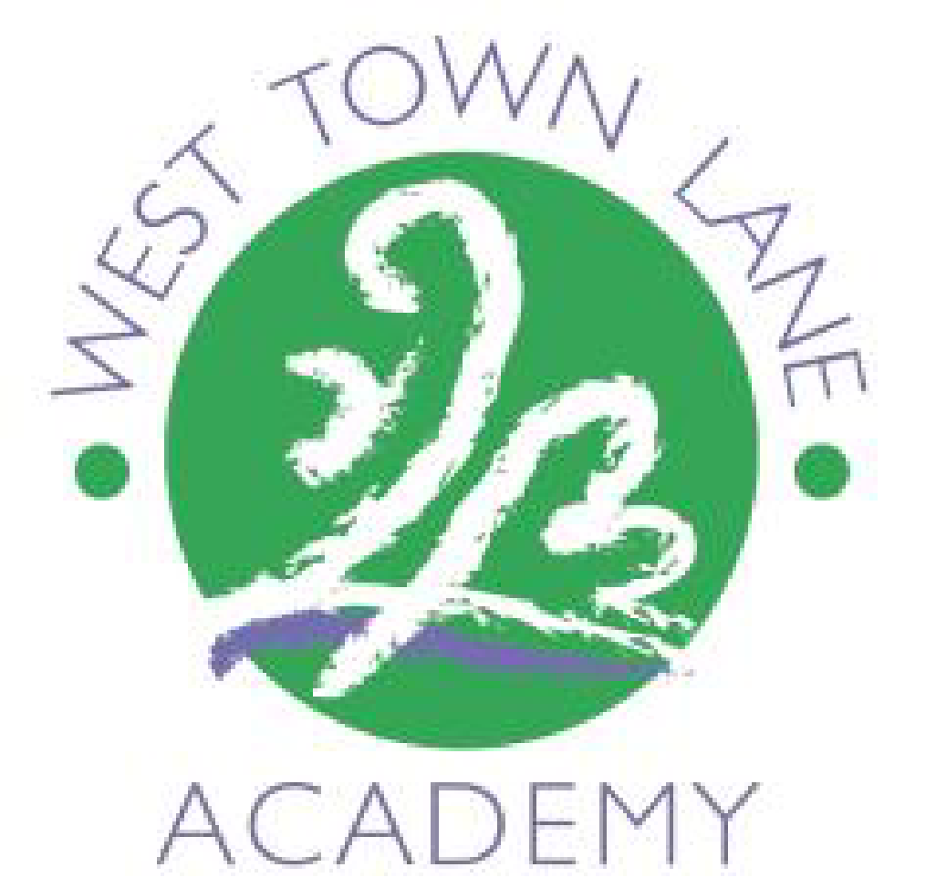
WEST TOWN LANE ACADEMY
Medium Term Plan

Year 3. Term 6 2026 Enquiry: How do UK capital cities compare?

 | Week 1  1.6.26 | Week 2  8.6.26 | Week 3  15.6.26 | Week 4  22.6.26 | Week 5  29.6.26 | Week 6  6.7.26 | Week 7/8  13.7.26  20.7.26
Wow/Celebration  Special events/trips/ visitors  (hidden curriculum) | Crazy hair event (5.6.26)  D.T week  (cooking)  Option to prep afternoon before.  3H 2.6.26  3B 3.6.26  3DS 4.6.26 | Trip to Legoland  11.6.26 | WTLA  summer Fair  19.6.26  Art week  NTS Maths  Assessments | Sports Week.  Sports Day 24.6.26  NTS Maths  Assessments  NTS Reading assessment | Ukulele performance  3.7.26 | Class swap tbc  Bloc climbing 10.7.26 | End of term 21.7.26  INSET  22.7.26  Week 7 Field trip to  Callington road nature reserve  (Geography)  3B 13.7.26  3H 14.7.26  3DS 16.7.26
English  Class books:  3H: An Otter Called Pebble by Helen Peters.  3B: The Wild Robot escapes by Peter Brown + non-fiction  3DS: The London eye mystery by Siobhan Dowd. | The Mystery of the Missing Masterpiece – play script (2 lessons).  1 writing basics recap.  + Handwriting | The Mystery of the Missing Masterpiece – play script (1 lesson).  1 writing basics recap.  Legoland recount. | The Mystery of the Missing Masterpiece – play script (2 lessons).  Writing week: Recap skills and opportunities for free choice writing.  Writing assessment.  + Handwriting | NTS Reading practice + assessment.  + Handwriting | Poetry week:  Senses poems  Cross curricular writing.  + Handwriting | SPAG skills and consolidation TBC (class needs):  Dictation  Dictionary recap  Nouns and pronouns | Consolidation  Reading aloud their own work – End of year celebration  End of year exception word recap.
English - Comprehension | Skills – Mixed modelling | Independent - Cumulative | Skills – Comparison intro (light) | Independent - Mixed | Skills - Review | Independent – End of year cumulative
WCGR | Spider in the bath  Poetry  Reading skill:  Preparing poems and play scripts to read aloud and to perform, showing understanding through intonation, tone, volume and action | Stars twinkle  Non fiction  Reading skill:  Reading and understanding of what they read by: listening to and discussing a wide range of non-fiction and  reference books or textbooks. | NO WCGR due to Art week | Swede pulls up carrot  Non fiction  Reading skill:  Checking that the text makes sense to them, discussing their understanding and explaining the meaning of words in context. | The Iron Man returns  Fiction  Reading skill:  Discussing words and phrases that capture the reader’s interest and imagination. recognising some different forms of poetry. | Measuring straight lines  Non fiction  Reading skill:  Retrieve and record information from nonfiction. | Catch up week
X tables | 5 minutes daily practise PP
X tables | Consolidation of facts learned so far in Year 3  Doubles/2 x table/square x table/5 x table  Pre teach 3 x 4 x 6x 7x tables as class appropriate
Maths | Time  Days and hours  Hours and minutes – start and end times  Hours and minutes – durations  End of unit assessment | Shape  Turns and angles  Right angles  Compare angles  Parallel and perpendicular  X table practice | NTS week | Shape  Recognise and describe 2D shapes  Recognise and describe 3D shapes  End of unit assessment  X table practice | Statistics  Interpret pictograms  Interpret bar charts  Collect & represent data  Two-way tables  End of unit assessment  X table practice | General  Mixed maths  X table practice | General  Mixed maths  X table practice
Spellings | Step 31:  division  invasion  confusion  decision  collision  television  erosion  vision  fusion  revision | Step 32:  difficult  important  length  perhaps  position  pressure  question  strange  special  purpose | Step 33:  pleasure  island  dislocate  disadvantage  decide  survey  exactly  bravely  ordinary  promise | Step 34:  freight  hourly  missed  suppose  plaque  descend  grotesque  automatically  daily  scented | Step 35:  teacher  scheme  history  mention  bawl  crescent  eighteen  regular  disable  mane | Step 36:  disappear  reaction  capable  personal  specifically  misunderstanding  freight  committed  forbidden  neighbour
Science | Forces and Magnets -Influential figure – Isaac Newton
 | No lesson in week 1 due to D.T | To compare and group materials and identify magnetic materials.  Investigate: ‘Are all metals attracted to magnets’? | No lesson in week 3 due to Art | To know magnetic forces can act at a distance, to observe how magnets attract or repel each other and attract some materials and not others.  Make a presentation/  poster to explain the learning in this unit about magnets and magnetism.  Present information to a younger audience (Year 1 or 2)  Oracy: Use language to the audience. (Imagine explaining how magnets, forces and friction work to a younger child). |  | To know magnetic forces can act at a distance, to observe how magnets attract or repel each other and attract some materials and not others.  Unit 5.2 Activity 1  Design and make a game using magnets.  Design and make a fridge magnet of a UK landmark.  (include Internet research)  Unit 5.2 Activity 2  Where are magnets used?
 | ‘We are opinion pollsters’
Computing | No lesson in week 1 due to D.T | To plan a survey on a topic. | No lesson in week 3 due to Art | To develop questions for a survey. | To create my own online survey. | To collect  data online. | To analyse and evaluate data collected.  To present my data. + Assessment task
Geography | How do UK capital cities compare?
Geography | No lesson in week 1 due to D.T | LO :To identify human characteristics of UK capital cities. | No lesson in week 3 due to Art | LO: To identify physical characteristics of UK capital cities. | How have the UK capital cities changed over time?  Cross curricular Writing - Explanation text  Plickers  Assessment:  How do UK capital cities compare? |  | Field work Callington road:  Geographical skills and Fieldwork:  Use fieldwork to observe, measure, record and present the human and physical features in the local area using a range of methods, including sketch maps.
History

Art and Design | Mixed media Street art
Art and Design | Week 3  Lesson 1: Research – looking at examples and a personal response (WAGOLL/ WABOLL) (Street Art or vandalism) and Converse- Recap and discuss the vocab from the progression map. Discuss them in relation to the examples. Discuss links to current enquiry.  ORACY RESPONSE REQUIRED (VIDEO)  L.O. To know the names and work of the artists Banksy and Swoon.  Lessons 2 and 3. Analyse- what skills will we need to succeed here? Which skills are we re-visiting? Which are new?  Explore- practice one specific skill using the chosen medium and tools. Make preliminary sketches, prototypes etc. Sketch book approach.  L.O. To use stippling and sponging. (freehand and use stencils).  Lesson 4. Refine- practice one or two drawing/painting/sculpture skills from the progression map  L.O. To make a stencil. (Cut out and practice.)  Lesson 5. Create-create a finished piece, or select the most successful one from the items they have made. Ensure vocabulary and skills are used and discussed throughout. L.O. To create street art. (Use walls in school grounds).  Lesson 6. Evaluate- written (where appropriate) appreciation of what was difficult, what was successful. Do they feel a safe and supportive atmosphere was created? Any change in pupil's attitude towards their own abilities?  L.O. To evaluate my finished product.
D&T | WEEK 1: DT BLOCK Design and make a meal from the UK. Influential figure = Andi Oliver, chef and host of ‘Great British menu’ TV programme, campaigning against racism in the food industry.  - Context. Influential person and their History.  - Research. Study examples. Evaluate existing products. (Where does food come in the UK/traditional British food/seasonality)  - Design. Select appropriate resources, include health and safety.  - Make the real product.  - Continue to make and evaluate.  - Evaluate. Was the product fit for purpose?  Oracy: Make precise language choices e.g. instead of describing a cake as nice using delectable.  Cross curricular Writing: Write up the recipe and instructions for making the meal.
Music | Ukulele tuition until 17.7.26  10 weeks (not 10.7.26)
PE | Health and fitness Agility - ball chasing skills Static balance – small base
RE | What does it mean to be a Sikh in Britain today?
RE | No lesson in week 1 due to D.T | To understand why the Gurdwara is important to Sikhs. | No lesson in week 3 due to Art | To learn what Sikh children value about the Gurdwara.  Oracy: To offer opinions that aren’t their own.  To speak with confidence in front of an audience.  No evidence | To identify what is inspirational or challenging for Sikhs in the UK. | To understand the importance of the turban to Sikhs.  ( ** Recap Sikhism/5Ks)  No evidence | To assess what we know about Sikhism.
PSHE  (Jigsaw) | Changing Me
PSHE  (Jigsaw) | To understand that in animals and humans, lots of changes happen from birth to fully grown, and that in mammals it is the female who has the baby. | To understand how babies grow and develop in the mother’s uterus and what a baby needs to live and grow.  No evidence | To understand that boys’ and girls’ bodies need to change, so that when they grow up, their bodies can make babies.  To identify how boys’ and girls’ bodies change on the outside during this growing up process. | To identify how boys’ and girls’ bodies change on the inside during the growing up process, and can tell you why these changes are necessary, so that their bodies can make babies when they grow up. | To start to recognise stereotypical ideas that I have about parenting and family roles.  Oracy: Reach shared agreement in discussions.  No evidence | Catch up week/extra discussions as required. | To identify what I am looking forward to about moving to my next class.  No evidence
Spanish | Language angels – ‘Los animales’
Spanish | In this unit, pupils will learn how to: • Recognise, recall, and spell up to 10 animals in Spanish with their correct indefinite article/determiner. • Understand better that articles/determiners have more options in Spanish than they do in English. • Use and become more familiar with the high-frequency 1st person conjugated verb ‘soy’ (I am), from the infinitive verb ‘ser’ (to be).  Support: Adapted sheets with scaffolds from Language Angels, oral rehearsal of ideas, visuals to go alongside vocabulary.

