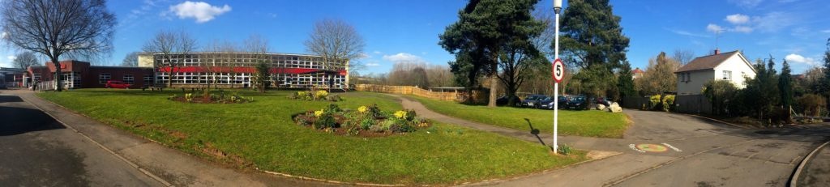
Welcome to
West Town Lane Academy
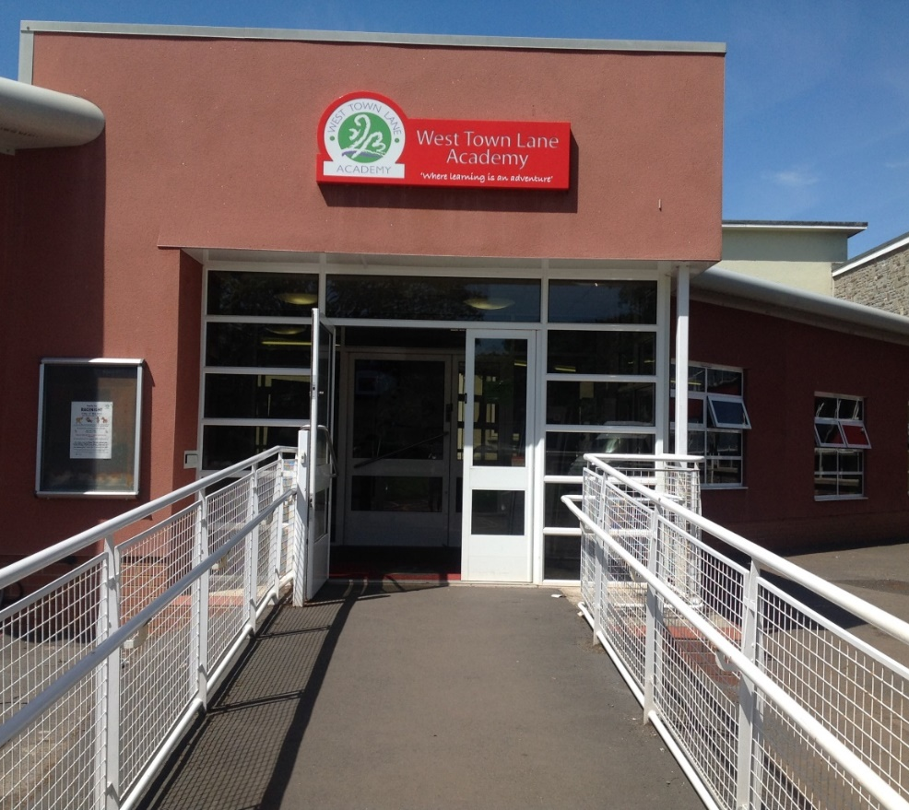

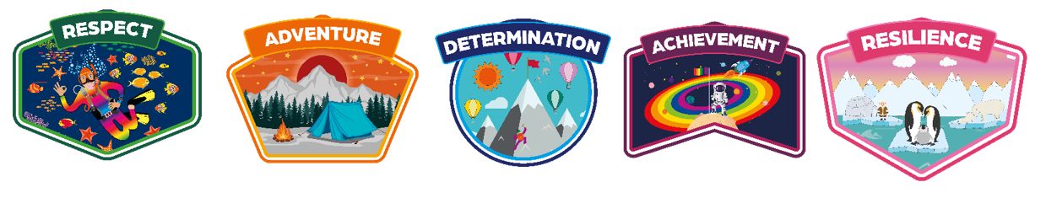

This is the Nursery!
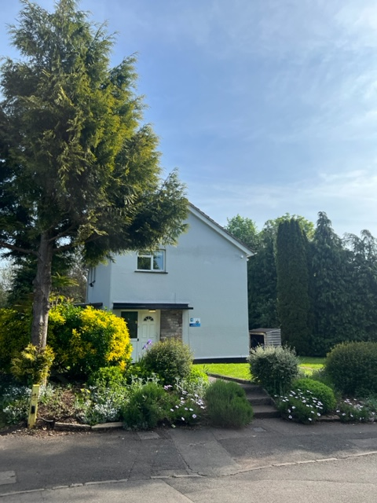

We are the Ladybirds class.

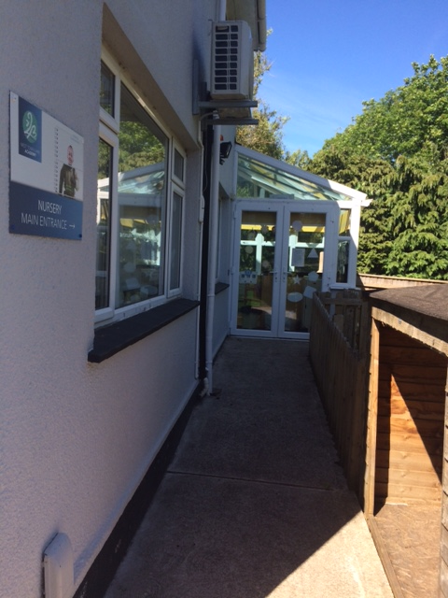
When you arrive you will line up along the path and come in through this door.

Welcome!
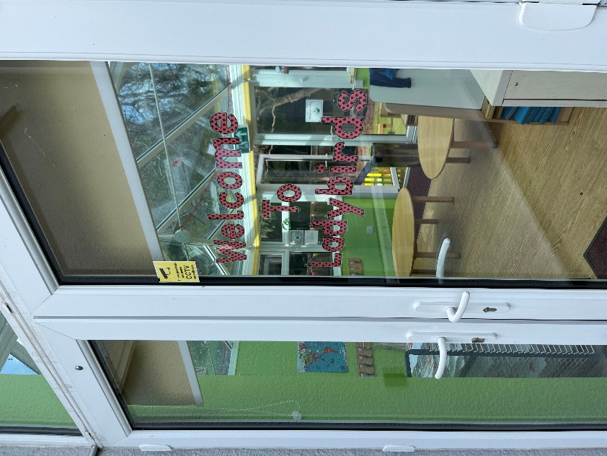



You will have a peg just like this to hang up your belongings. You will have somewhere special to keep your lunchbox, snack and drink.
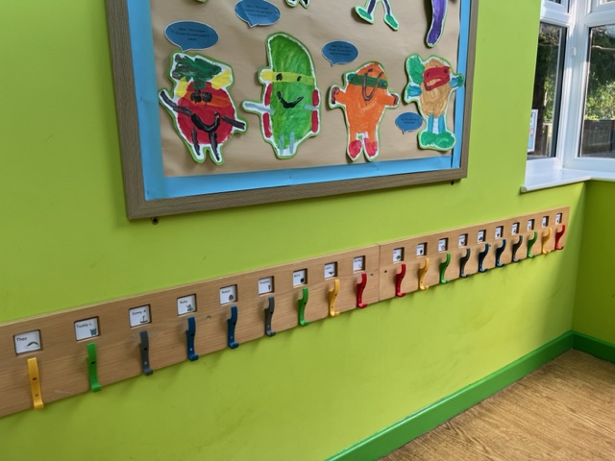

We have yummy school dinners or a packed lunch from home!

You will be able to go to the toilet and wash your hands in the bathroom.

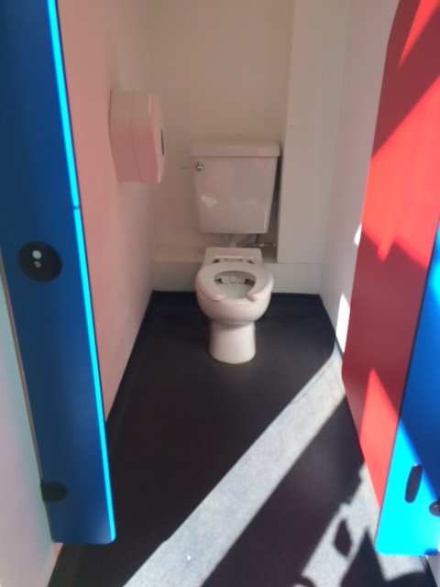
The toilets and sinks are just the right size for nursery children!

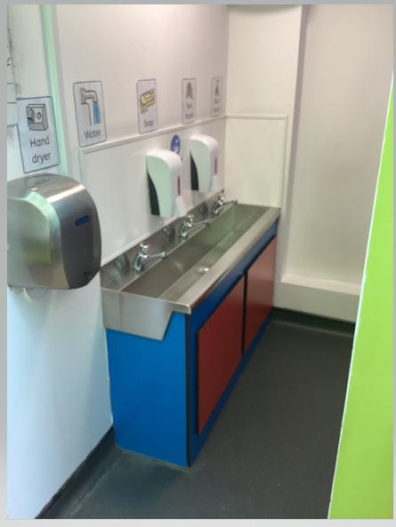

There are lots of rooms for you to play in and resources to explore!
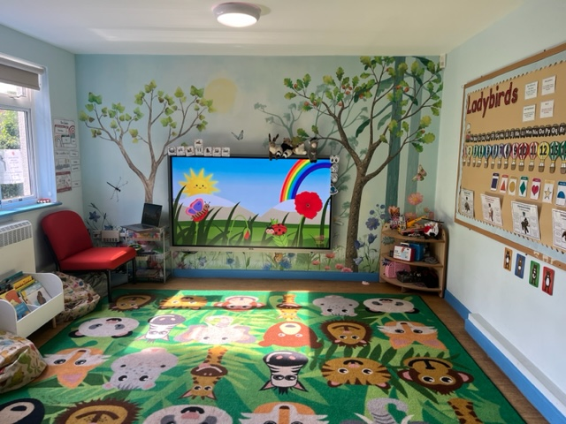

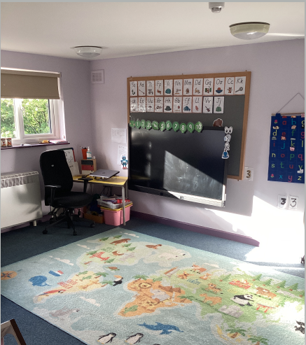
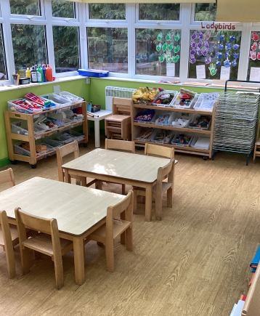

We have blue, green and purple room!

We have a great outdoor area for you to play in to!
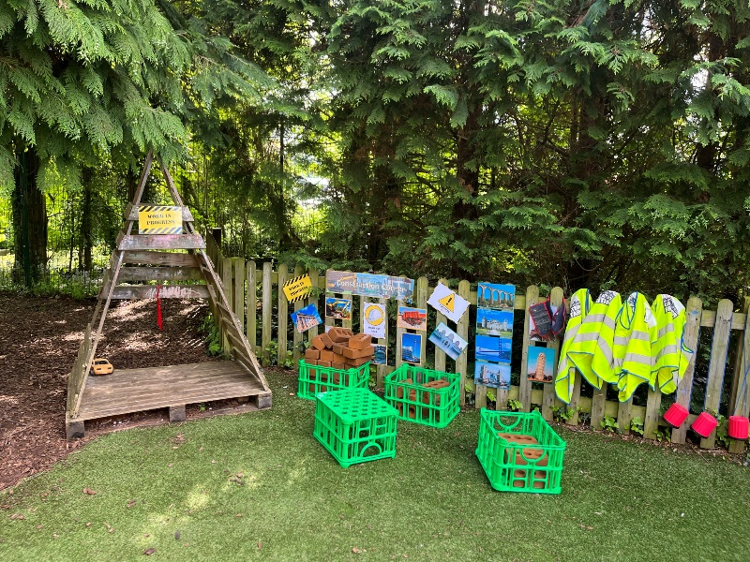
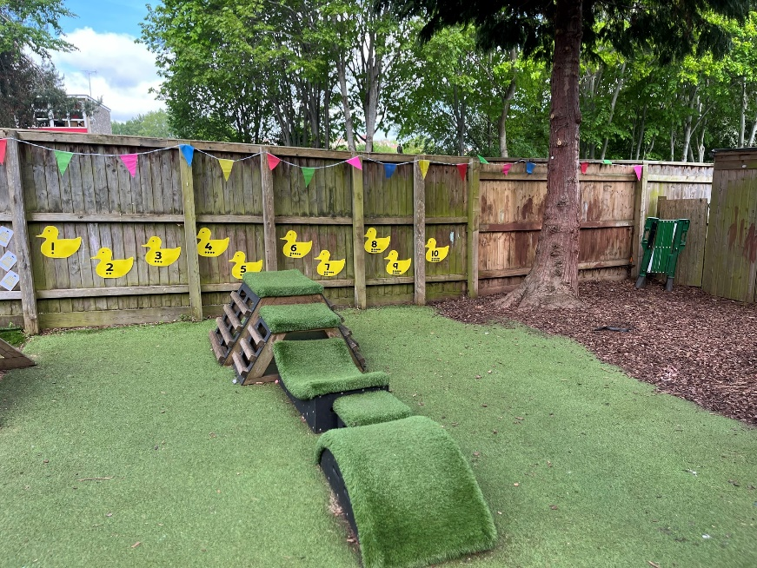
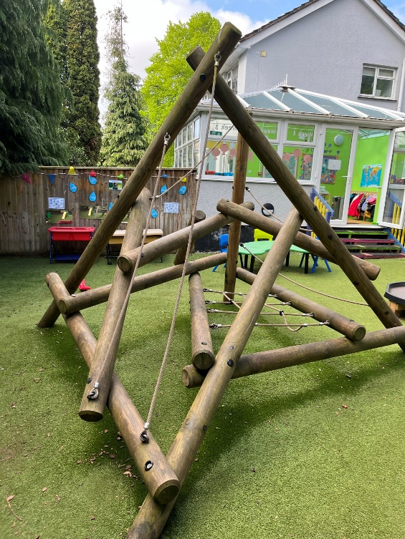

We have bikes and scooters to ride!

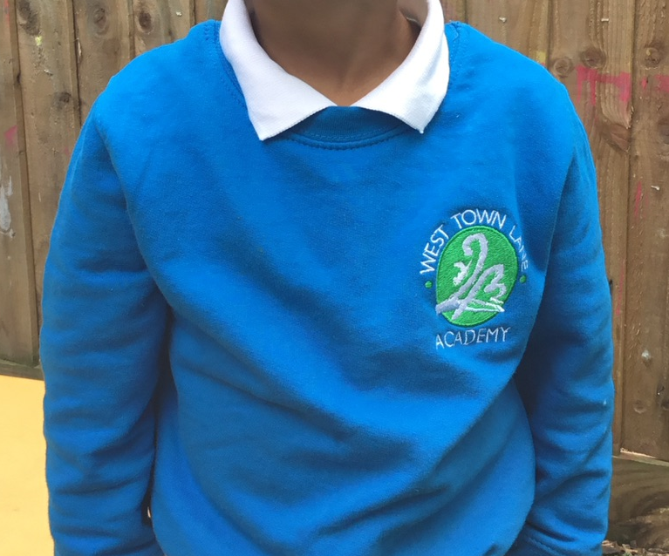
We have smart jumpers to wear!

Our Ladybirds Teachers:

Mrs Owen – Monday, Tuesday, Wednesday

Mrs Lewis – Thursday, Friday.

At lunch time you can have a school dinner or your own packed lunch. We walk to the Aspire hall to eat out lunch with our lovely lunchtime staff.
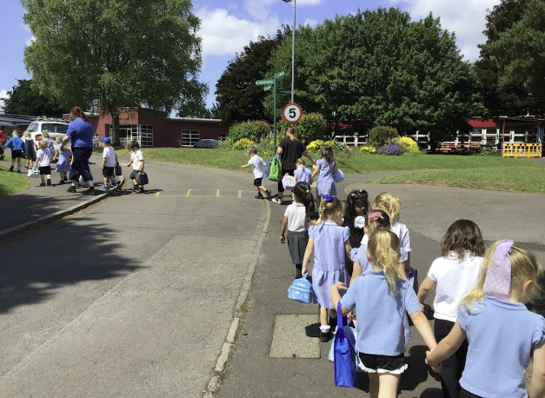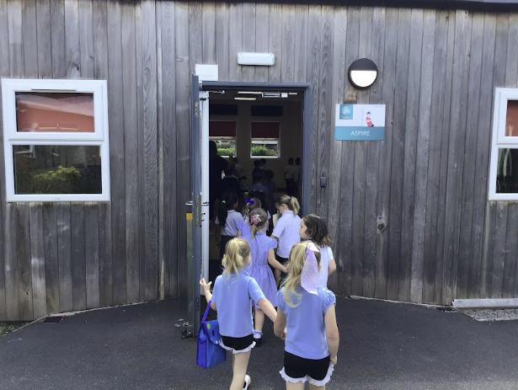

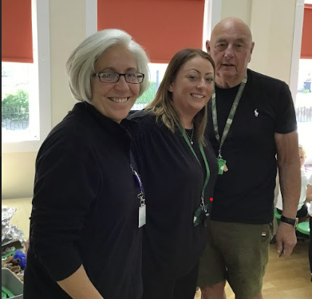

Sabrina, Kelly and Maurice

