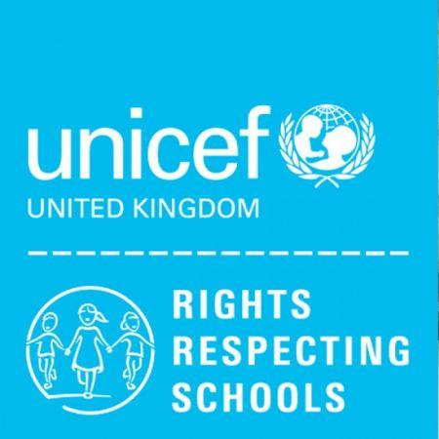
WEST TOWN LANE ACADEMY
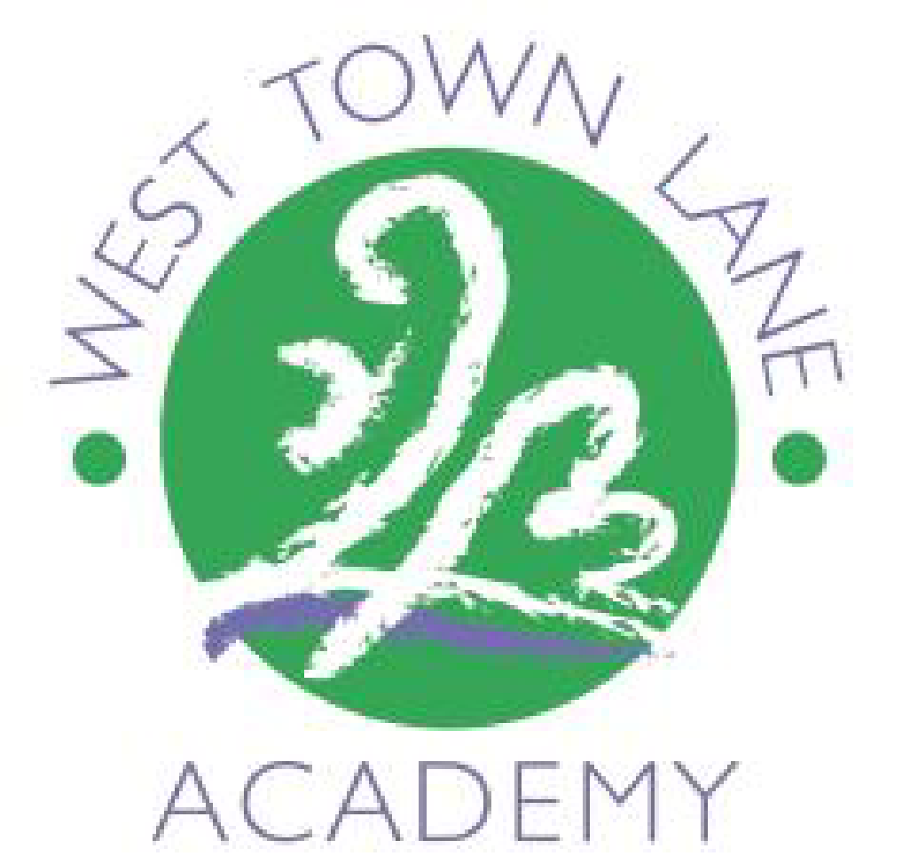
Medium Term Plan
Year 2 Term 1 Enquiry: What Happened on Pudding Lane?

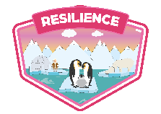
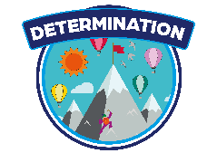
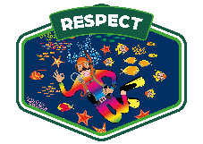

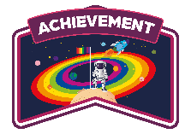
 | Week 1 | Week 2 | Week 3 | Week 4 | Week 5 | Week 6 | Week 7
Special events/trips/  visitors |  |  |  | NSPCC Speak out Stay Safe – Monday 28th and Tuesday 29th.  Scooter skills –  Thursday 24th |  |  | Celebration –  Recreating the GFoL
English  Class Book  2WL – The Enchanted Wood By Enid Blyton  2D- Einstein the Penguin  2VR- George’s Marvelous Medicine | Nonfiction: Introducing ourselves | Nonfiction: Introducing ourselves  Comprehension Skills – Vocabulary context | Simple narrative: Traditional Tales  Comprehension  Indep – Vocab-led | Simple narrative: Traditional Tales  Comprehension  Skills – Word choice | Non-fiction: Diary entry  Modelled text: Samuel Pepys  Comprehension  Indep – Mixed | Non-fiction: Diary entry  Modelled text: Samuel Pepys  Comprehension  Skills – Morphology intro | Finishing off diaries  Extra lessons if needed: Fire acrostic poems  Comprehension  Indep – Mixed
SPAG | Subordination when/If/that/because  e.g.  I am happy when..  I am sad if … | Subordination when/If/that/because  e.g.  I am happy when..  I am sad if … | Co-ordinating conjunctions:  But, or, and | Co-ordinating conjunctions:  But, or, and | Tense: Past tense  Adding ‘ed’ | Tense: Past tense  Adding ‘ed’ | Adjectives
WCGR (Reading) |  | Dogger (Fiction)* | Dolphins  (Non-fiction)* | Like an Animal (Poetry)* | Timid Tim & the Cuggy Thief (Fiction)* | Big Cat, Little Cat (Non-fiction)* | What the Ladybird Heard (Poetry)*
Maths | Number – Place Value | Number – Place Value | Number – Place Value | Number – Place Value | Number – Addition & Subtraction | Number – Addition & Subtraction | Number – Addition & Subtraction
Phonics | Phase 5 Recap
Science | To demonstrate squashing, stretching, bending and twisting. | Which objects can be changed by squashing, bending, twisting and bending? | Which objects can be changed by squashing, bending, twisting and bending?  (Playdough activity) | To identify rigid and flexible materials.  use sentence stems to signal when they are building on or  challenging others’ ideas. | To find out how shapes of solid objects can be changed by performing simple tests. (Sock stretching investigation) |  | Performing a simple test – Flying mouse experiment.
Computing | To plan a sequence of movements and revisit ideas about programming and algorithms. | To become familiar with moving a sprite in Scratch Jr. | To plan a sequence of instructions to move sprites in Scratch Jr. | To create, test and debug programs for sprites in Scratch Jr. | To work with input and output in Scratch Jr. | To use repetition in their programs. | To design costumes for sprites.
Geography |  |  | To locate London on a map.
History | Enquiry Introduction | To know where and why the GFoL started  ask questions to find out more about a subject. | To understand the chronology of the GFoL.  mostly speak in grammatically correct sentences | To know how we can find out about historical events using different sources such as artifacts. | To identify similarities and differences between now and the past | To know how people were affected by the fire and what changes did it bring.  Build houses with boxes. | Plickers Assessment  Great Fire of London Celebration activity
Art and Design | Introduction to water colour artists and exploring artwork | Exploring primary colours and blending | To practice blending watercolours. | NSPCC workshop | To produce a fiery water colour background. | Create template black paper foreground. | Evaluation
D&T
Music | Charanga – Pulse Rhythm and Pitch
Music | Lessons 1 & 2* |  | Lessons 3 & 4* |  | Lesson 5 & 6* |  | Record for Music evidence
PE | Coordination – Foot work  Static balance – One Leg
RE |  | To know that Christians believe people are valuable and unique. | To re-tell the Christian story of The Good Samaritan.  confident delivery of short pre-prepared material. | To know how Jewish people help the world.  show body language associated with careful listening | To understand the importance of The Golden Rule (Mother Theresa) | To know the Christian Creation Story | How should we care for others and the world and why does it matter?  Unit recap
PSHE | To create our class charter  I can identify some of my hopes and fears for this year. | I understand the rights and responsibilities for being a member of my class and school. | I listen to other people and contribute my own ideas about rewards and consequences. | I listen to other people and contribute my own ideas about rewards and consequences. | I understand how following the learning charter will help me and others learn. | World Mental Health Day | I know why following the Learning Charter is fair
Spanish

