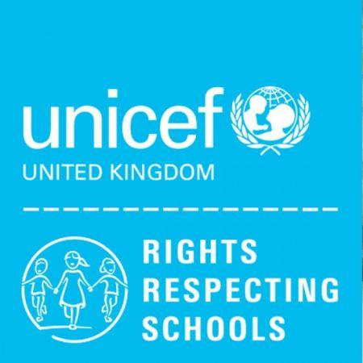
WEST TOWN LANE ACADEMY

Medium Term Plan

Year 2 Term 6 Enquiry: How can we look after ourselves and our planet?

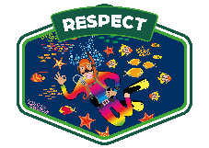


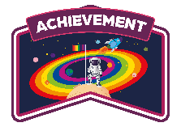
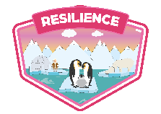
 | Week 1 |  |  | Week 2 |  | Week 3 |  | Week 4 |  |  |  | Week 5 |  | Week 6 |  |  | Week 7
Special events/trips/visitors | Longleat- Thursday 4th June |  |  | Phonics Screen |  |  |  | Maths Assessments  Wednesday 24th June Sports Day |  |  |  | Reading Assessments  Wednesday 1st July - Y2 (Tennis) |  |  |  |  | (Week 8, 2 days)  Inset day Wednesday 22nd July
English  Class Book:  2D – Magic Faces  2DL – Unipiggle  2VR – The Breakfast Club Mysteries | Recount Trip to Longleat – Assessed write |  |  | Character Description – Assessed write |  | ‘The True Story of Snow White’  Immersion |  | ‘The True Story of Snow White’ –Innovation |  |  |  | ‘The True Story of Snow White’ -Innovation  Reading assessment Paper 1 and 2 |  | Poetry/riddles  ‘The Papaya that Spoke’ - Immersion |  |  | ‘The Papaya that Spoke’ - Innovation
SPAG | Time connectives,  Adverbs, Adjectives |  |  | Adjectives,  Adverbs,  Different sentence types |  | Adjectives,  Adverbs,  Different sentence types |  | Adjectives,  Adverbs,  Different sentence types |  |  |  | Adjectives,  Adverbs,  Different sentence types |  | Conjunctions,  Present tense,  Adjectives,  Question sentence
Reading skill | To recap comprehension skills |  |  | To learn cumulative comprehension skills |  | To practice mixed comprehension questions |  | To learn cumulative skills |  |  |  | To review our comprehension skills |  | To learn cumulative skills
WCGR (Reading) |  |  |  | Jake the Good Bad Dog (Fiction) |  | Your Senses (Non-Fiction) |  | The Bog Baby (Fiction) |  |  |  | Reading assessment  Paper 1 and 2 |  | The HodgeHeg (Fiction)
Maths | Statistics  Arithmetic recap |  |  | Statistics  Arithmetic Recap (Addition, Subtraction) |  | Arithmetic Recap  (Addition, Subtraction, Mulitplication, Division & Fractions of Amounts) |  | Problem Solving- Two step questions  Mass, Capacity and temperature  Arithmetic test  P&R test |  |  |  | Mass, Capacity and temperature |  | Position & Direction |  |  | Position & Direction
Phonics | Phase 5 Recap
Science | What do animals including humans need to survive? |  | Sowing basil and rocket to use on top of pizza |  |  | Importance of the right amount of different foods - Designing a healthy pizza  answer using clear sentences |  | Sports Day |  |  |  | TENNIS |  | Make pizzas – hygiene and healthy food choices |  |  | Flyer to advertise our healthy pizzas!  Develop an awareness of audience e.g. what might interest a certain group.
Computing | We are Safe Researchers
Computing | Scoping a topic and breaking down questions.  build on others’ ideas in discussions. |  | Looking for information/  Searching safely and effectively using search engines |  |  | Preparing a Presentation |  | Sports Day |  |  |  | Preparing a Presentation cont. |  | Giving a presentation  confident delivery of short pre-prepared material. |  |  | End of Unit Reflection
Geography | To explore our enquiry question.  ask questions to find out more about a subject. |  | Pupil report comment |  |  | What Impact are Humans Having on the Planet? |  | How Can Humans Reduce Their Impact on the Planet? |  |  |  | TENNIS |  | Influential Figure - Greta Thunberg |  |  | Enquiry Assessment - Plickers
History
Art and Design
D&T | LONGLEAT |  | Influential Figure Introduction – Jamie Oliver |  |  | Understanding where food comes from |  | Tasting fruits |  |  |  | Evaluating healthy snacks  answer using clear sentences |  | Designing a healthy snack |  |  | Make & sell a healthy snack
Music | Charanga – MMC Scheme  Exploring Improvisation
Music | Lessons 1 & 2- I wanna play in a band. |  |  |  | Lessons 3 & 4- Music is all around. |  |  |  |  |  | Lesson 5 - Saying sorry. |  |  |  |  |  | Lesson 6- Assessment
PE | Health & Fitness  Agility – Ball Chasing  Static Balance – Floor Work
RE | LONGLEAT |  | To understand how Muslims treat the Qur’an to show it’s holy. |  | To recognise ways in which Jewish people treat their holy book. |  |  |  | To learn and understand a story from the Torah (Moses).  use sentence stems to signal when they are building on or  challenging others’ ideas. |  | Which story do Muslims tell about Prophet Muhammad? |  |  | To learn the story of Jonah from Jewish and Christian texts. |  |  | To understand the meaning behind the story of Jonah.
PSHE  (Jigsaw)  awareness of others who have not spoken and to invite them into discussion | To recognise cycles of life in nature. | To understand the natural process of growing from young to old. |  |  | To recognise I have changed since I was a baby. |  | To recognise the physical differences between boys and girls and use the correct names for parts of the body. |  |  |  |  |  | To identify how I am feeling about moving to Year 3. |  |  | To identify what I am looking forward to when I move to my next class.
Handwriting | ULS  Unit 6 Handwriting
Spanish | Colours & Numbers – Lesson 1 |  | Colours & Numbers – Lesson 2 |  |  | Colours & Numbers – Lesson 3 |  |  |  | Colours & Numbers – Lesson 4 |  | Colours & Numbers – Lesson 5 |  | Colours & Numbers – Lesson 6

