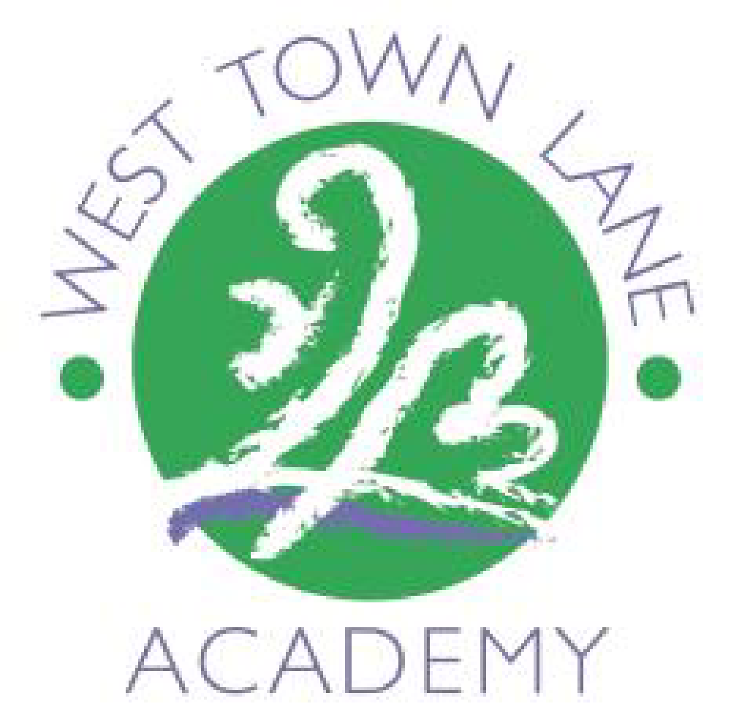
WEST TOWN LANE ACADEMY

Year: 4 Term: 6 Enquiry : Where in the world do they speak Spanish?

SDP: The wider curriculum is further developed so that it provides rich opportunities for pupils to develop and deepened their skills in reading, writing and mathematics.

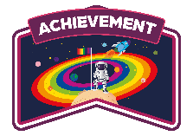

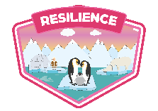
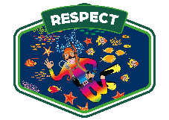

 | Week 1 | Week 2 | Week 3 | Week 4 | Week 5 | Week 6 | Week 7 | Wk 8  2 day week  INSET day
Special events/trips/visitors  (hidden curriculum) | Crazy hair day | Multiplication tables check (MTC) | Tobogganing – Thurs 18th June  Summer Fayre – Friday 19th June | Sports Week  Sports day – Wed 24th | End of year tests | Geography Field Trip | DT WEEK – paella | End of year activities
English  Class books  4PHW – (first finish Little Manfred due to missed time during camp) The Lion the Witch and The Wardrobe, C.S. Lewis  4LW The Secret Garden  4JW Finish To Boy to beat the Gods then Esio Trot | Discussion text / poetry – The Land of Roar  Imitation  Know and use language that is acceptable in formal and informal situations with increasing confidence  Comprehension skill: Literal  Inference  Vocab from the new text | Discussion text / poetry – The Land of Roar  Innovation  Empathise with an audience. | Discussion text / poetry – The Land of Roar  Invention | Non-Chronological Report  Imitation | NTS Reading test  Non-Chronological Report  Innovation  Know and use language that is acceptable in formal and informal situations with increasing confidence  Comprehension skill  Inference, retrieval  Vocab from new text | Non-Chronological Report  Invention | Haiku Poetry | Poetry
WCGR | Dragonsitters Island | MTC instead  (Grrrrrr if time?) | Chinese New Year | The Pudding Like a Night in the Sea | The Green Ship | The Little Ghost | Daddy Fell into the Pond | End of Year activities
Maths | Time  To convert between analogue and digital time.  To convert between analogue and digital time in 24 hour clock.  End of block time assessment. (2 lessons/ MTC revision x 2) | No maths Monday  MTC / Shape –  Quadrilaterals, polygons | Shape –  lines of symmetry, complete a symmetrical figure | Statistics –  Interpret charts, comparison, sum and difference, interpret line graphs, draw line graphs / Position and direction –  Describe position using coordinates, plot coordinates | Revision & end of year assessments  End of year tests and revision lessons.  Understand how to answer questions that require more detailed answers and justification | Position and direction – draw 2D shapes on a grid, translate on a grid, describe translation on a grid | Consolidation  End of year revision based gaps, ready for year 5. | Summer quizzes.
Phonics/SPAG | - Direct speech  - Subordinate clauses | - Embedded clauses  - Adverbs | - Editing and upgrading  - Fronted adverbials with a comma  - Possessive apostrophes  - Direct speech | - Pronouns  - Fronted adverbials  - Possessive apostrophes | - Poetry performance demonstrating intonation and expression | - Editing and upgrading  - Fronted adverbials with a comma  - Conjunctions  - Possessive apostrophes | End of year activities
Science | Teeth – I can identify teeth and their functions | To plan a science experiment on tooth decay  Ask probing questions  Split over 2 weeks | To make accurate observations, record results and draw conclusions. | Sports Day. | To understand the function and location of the digestive organs. | Digestive system- I can describe the journey of food | DT | Food Chains – Prey and predators
Computing | Micro:Bits  Explore the MakeCode environment and learn about the BBC micro:bit | Micro:Bits  Work out how a match-scoring program has been written | Micro:Bits  Modify a rock-paper-scissors game to make a sorting hat game | Sports week | Micro:Bits  Modify their sorting hat game to make a dice game | Micro:Bits  Plan their own micro:bit project Micro:Bits  Write and test their own micro:bit project. | DT | End of year activities
Geography | What is life like in other Spanish speaking countries. (Factfile, students complete their own research.) | What do the lines on our map mean?  Geographical terminology- Label a map. | What’s the link between the equator and the temperature?  Linking Spanish countries to the geographical close to the equator and the climate of those countries. terms. Research with how | No geography due to sports day | How important is the trade industry to Spanish speaking countries?  Trade link comparison. Compare the Spanish trade industry from Spain VS a developing country such a Guatemala | Field work, compare Gracia, Barcelona with Brislington, Bristol. | DT | Plicker – end of unit assessment (Possibly wk 7)
History

Art and Design | Who is Picasso- fact file  Explore and discuss a range of art by Picasso  Display different pics around the class- using key vocab (Art progression map), groups go around and evaluate on A3. |  | Explore colours and shapes to convey feeling  Explore colours to portray feelings- children can experiment with mixing colours etc. What colour would they like to use to convey how they feel.  Practice using shape and colour to represent facial features. | Roll a Picasso activity (if time due to sports week.) | Use coloring pencils to complete Picasso inspired self-portrait in sketch books  Evaluate Picasso inspired portraits | Create a final version of their portraits using A4 paper and paint  Each year 4 class to set up their class like and art gallery. Children to walk around between classes and evaluate each other’s art.  consider the impact of their words on others when giving feedback.
D&T |  |  |  |  |  |  | End of year activities
Music | You can see it (part 1) | You can see it (part 2) | Music is all around | The octopus slide | Connect | Assessment checkpoint | DT
PE | Health and Fitness  Agility - Ball Chasing Skills  Static Balance - Small Base | Health and Fitness  Agility - Ball Chasing Skills  Static Balance - Small Base | Health and Fitness  Agility - Ball Chasing Skills  Static Balance - Small Base | Health and Fitness  Agility - Ball Chasing Skills  Static Balance - Small Base | Health and Fitness  Agility - Ball Chasing Skills  Static Balance - Small Base | Health and Fitness  Agility - Ball Chasing Skills  Static Balance - Small Base | End of year activities
RE | Sikh Festivals (No time in term 5 due to camp/bank holidays/inset) | Divali – why is Divali significant to Hindus. Resource heavy lesson. | What is the significance of Baptism to Christians? | Sports week | How do Jewish people mark becoming an adult? | What ceremonies do Hindus mark in the journey of life? | Sikh Weddings / To compare wedding ceremonies from different communities. ORACY | End of year activities
PSHE  (Jigsaw) |  | Workshop | Workshop | Having a baby (Short Oracy)  Workshop | Puberty | Circles of change | Accepting change | I am ready for year 5
Spanish |  | Goldilocks- Sequence the story | Tobogganing | Sports day | Goldilocks – Create a storyboard for Goldilocks- putting in key vocabulary and phrases along my map | Goldilocks – Create a storyboard for Goldilocks- putting in key vocabulary and phrases along my map | DT | Goldilocks – Create a storyboard for Goldilocks- putting in key vocabulary and phrases along my map

Geography Field Trip
Where do people get food?
- Shops
- Restaurants/ cafes
Where do people live?
Where do people go to school?
Where do people go for fun?
Green Spaces?
How do people get around?

